FOX PACKAGING SERVICES
20 MELFORD DR. UNIT 11 & 12
SCARBOROUGH, ONTARIO M1B 2X6 CANADA

TEL: (416) 289-3699 FAX (416) 289-8987 1-888-918-FOX1 (3691)
www.foxpkg.com email: sales@foxpkg.com

FPS3000FT
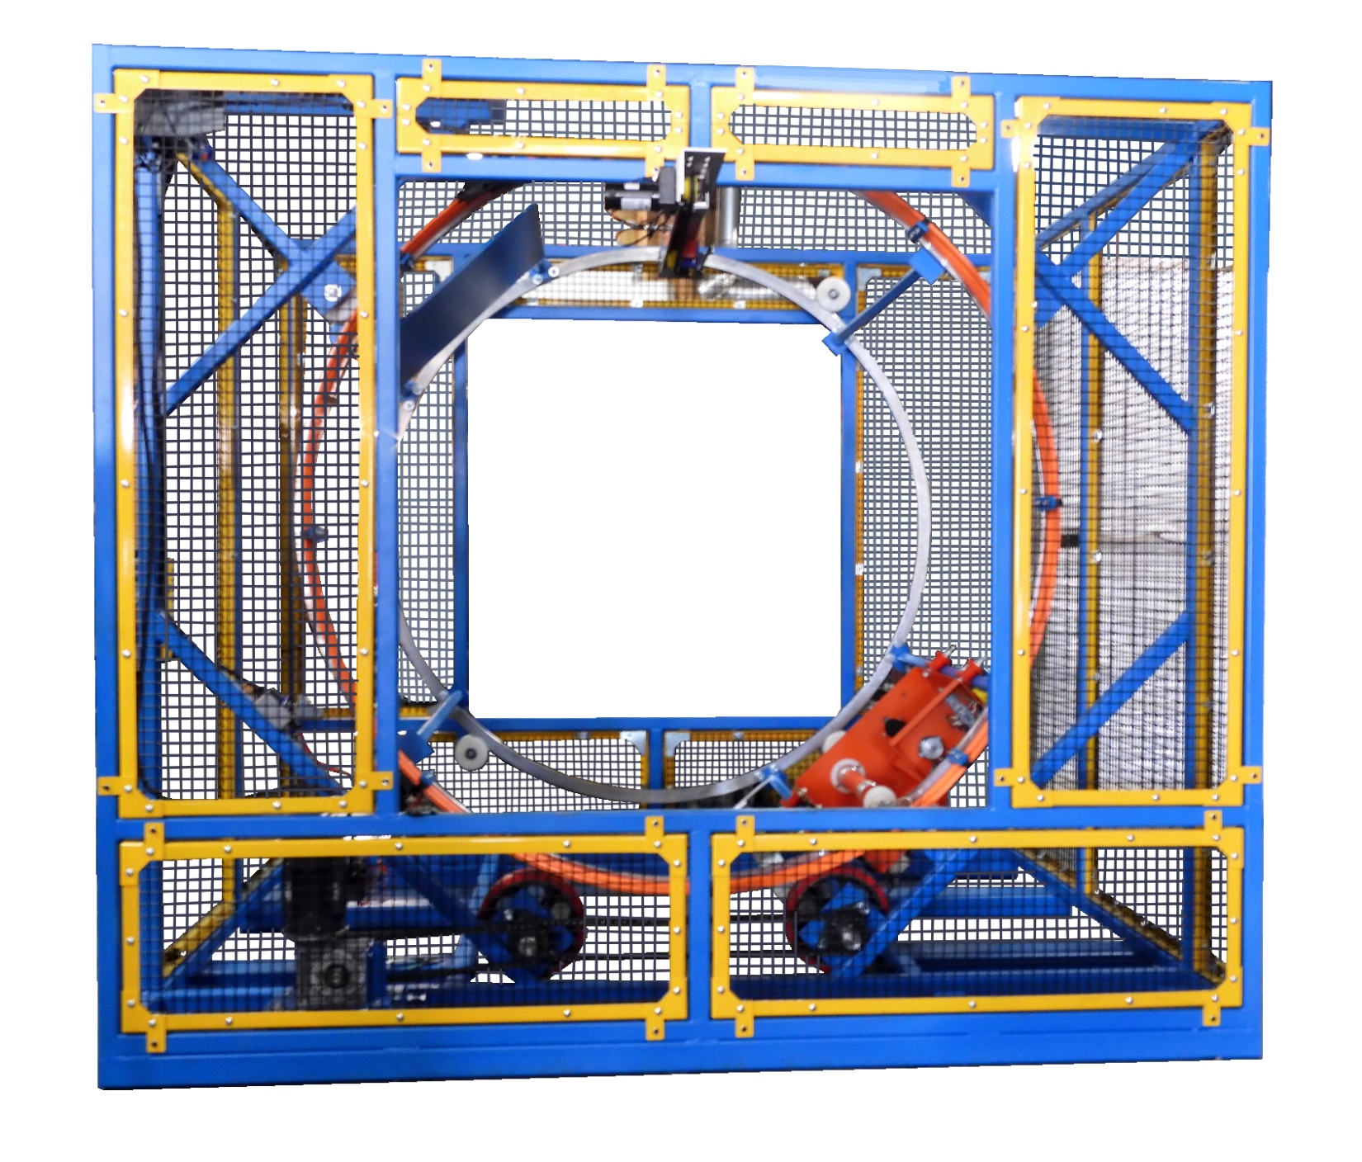

We would like to introduce our new Fork Truck Orbital the FPS3000FT.
A whole new concept in wrapping a skid of product securing the load solidly to the skid.

Competitors:
1/ Most all wrappers are manual.
2/ The fork truck operator must get off the truck, manually attach the film to the skid, start the ring turning, then push the whole machine manually forward and backward. This is a huge lose of time to wrap each load.
3/ Another type is automatic, but the fork truck operator must move the fork truck backwards to wrap the load length. There could be a hazard if the operator does not see passing traffic.

FOX FPS3000FT:
1/ Fully automatic no need to attach or cut the film
2/ No air required to operate film clamp/cutter
3/ No need to move the fork truck back while product is wrapped
4/ It takes ½ the time wrap a load
5/ Requires 115V15A dedicated wall outlet or a plug with no other equipment
plugged in
FPS3000FT SPECIFICATIONS

Capacity: To accommodate product: Load Width 48”
Load Depth 48”
Load Length 48”
Longer loads can be wrapped as well.

Controls:

-Main panel Nema 12 (18” x 24”) cabinet on each unit)
-Electric requirements 120V/15A/60HZ dedicated line (115V wall plug with no other devices
plugged in.)
-Main breaker 15A
-PLC 32 I/O
-Delta 7” Colored Touch Screen
-Automatic film clamp and film cutter
-Auto home alignment
-Ring jog
-Safety lockout switch on door (shuts off control power
-Key fob to start the wrapper form truck (two provided)
-All controls 24V AC
-Ring drive motor 1HP AC 230V with brake
-Full detailed electrical schematic
-Electrical controls name brand, obtainable from local suppliers

Ring:

-Two 80” ID precision machined steel rings
-Machined urethane ring support wheel with two sealed bearings (qty. of 4 per ring)
-12” dual urethane drive wheels with 1-3/16” axles
-#60 chain and sprocket drive
-Ring speed from 0 to 30 rpm
-Pass through height of product at 18” approximate
-Ring support frame 1/4” steel plate

Film carriage:
-20” mechanical friction tensioning film carriage
-Supports film rolls 20” long by 9” diameter
-Easy fill tensioning adjustment
-Roller provided in ring to narrow the gap for small product. Manual operation to put in place the roller.
The film carriage travels back/forth on two tracks while the ring rotates
The operator doesn’t have get off the truck and push the machine back/forth

Remote Control Start/Stop Wrapper:

-Radio controller with two remote key fobs provided with the wrapper
-Operator can stay on the truck
-Automatic film clamp and cutter

How the FS3000FT Works:

Our film carriage travels on two support tubes which are attached between the two rings. A chain attached to film carriage and driven by a gearbox motor combo pulls the carriage forward and back. Carriage limit stops prevent over travel. As the rings turn the carriage travels forward and back to wrap the load end to end.

Please view the videos below to learn more:
(COPY AND PAST ON GOOGLE SEARCH TO VIEW)
https://www.dropbox.com/sh/l86hini78pkhsvb/AAAIM5BPh12rkxD0ddYIIW3Ha?dl=0
(CLICK ON THE SYMBOL TO VIEW THIS VIDEO)

